**X. Stakeholder Management**

**X.1 Overview**

Stakeholder management is a crucial part of the project management plan. It mainly focuses on identifying project stakeholders and promoting the communication between project and stakeholders, so as to meet the requirements of project stakeholders and facilitate the timely solution of possible problems.

**X.2 Management Method**

According to Power Influence Grid in data representation methods [1], we can identify the type of relationship the project needs to establish with each stakeholder to distinguish the various stakeholders of this project. In addition, we manage stakeholder participation through Stakeholder Engagement Assessment Matrix [2]. And with the guidance of the grid, we can generate a reasonable communication plan with all of the stakeholders.

**X.3 Stakeholders Identification**

Based on the principle of power influence grid, all of the stakeholders can be divided into four categories called ‘A B C D’ which represent different kind of relationships that need to be built. These relationships are as followed:

A: satisfaction

Stakeholders in A are characterized by "great power and low attention to project results", so it is crucial to win the support of relevant parties in A for the success of the project

B: The key management

They have a high level of authority over the project and are concerned about the results of the project. The project manager should "focus on management, timely report, and take forceful actions to satisfy the relevant parties in B.

C: Keep inform

Despite the low power of the relevant parties in C, they pay attention to the results of the project. So, the project manager is "keep inform" of the status of the project. To maintain the satisfaction of the parties concerned in C. Underestimating the interests of the parties involved in C can have dangerous consequences and may lead to opposition from the parties involved in C.

D: Supervision

Properly address the needs of interested parties in D. Related parties in D are characterized by "low power and low attention to project results", so the project manager can mainly "supervise them with the least effort".

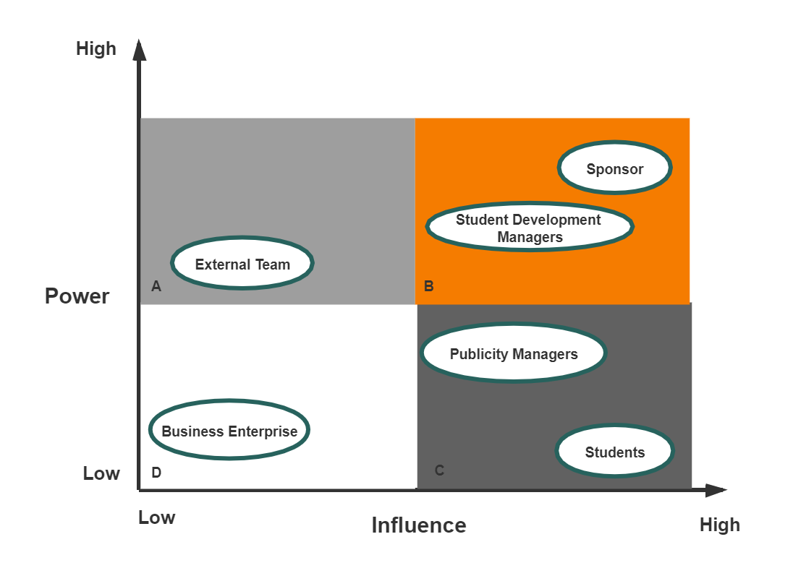

Figure x.1 Power Influence Grid

Table x.1 Identified Stakeholders

|  |  |  |
| --- | --- | --- |
| Category | Stakeholders | Interest |
| A | External implementation team | Responsible for the overall design of the platform and the implementation of specific function |
| B | Sponsor | Give guidance and suggestions to the project, gain support for the project by presenting it to the rest of the organization |
| B | UNSW student development managers | To find future directions for more graduates |
| C | UNSW publicity managers | Promote the school through better employment data advantages |
| C | UNSW students | Allow UNSW students have better chance to find their dream job after graduation |
| D | Business enterprise | Have better chance of hiring the right graduates |

**X.4 Stakeholders Engagement**

Stakeholder Engagement Assessment Matrix is used to compare the current level of stakeholder participation with the expected level of participation. Stakeholder Engagement Assessment Matrix divide stakeholders into five positions: Unaware, Resistant, Neutral, Supportive and Leading.

Table x.2 The Engagement Level Of Stakeholders

|  |  |  |  |  |  |
| --- | --- | --- | --- | --- | --- |
| Stakeholders | Unaware | Resistant | Neutral | Supportive | Leading |
| External implementation team |  |  | C |  | D |
| Sponsor |  |  |  | CD |  |
| UNSW student development managers |  |  | C |  | D |
| UNSW publicity managers |  |  | C |  | D |
| UNSW students |  |  | C |  | D |
| Business enterprise | C |  | D |  |  |

C = Current D = Desired

In Table x.2, C represents the current level of participation of each interested party, while D is the level of participation (expected) assessed by the project team as necessary to ensure the success of the project.

Reference

[1] Project Management Institute. (2017). A guide to the Project Management Body of Knowledge (PMBOK guide) (6th ed.). 13.1.2. Project Management Institute.

[2] Project Management Institute. (2017). A guide to the Project Management Body of Knowledge (PMBOK guide) (6th ed.). 13.2.2. Project Management Institute.